Main Screen : Search bar, buttons to select to view your current collection as well as decks you have built.

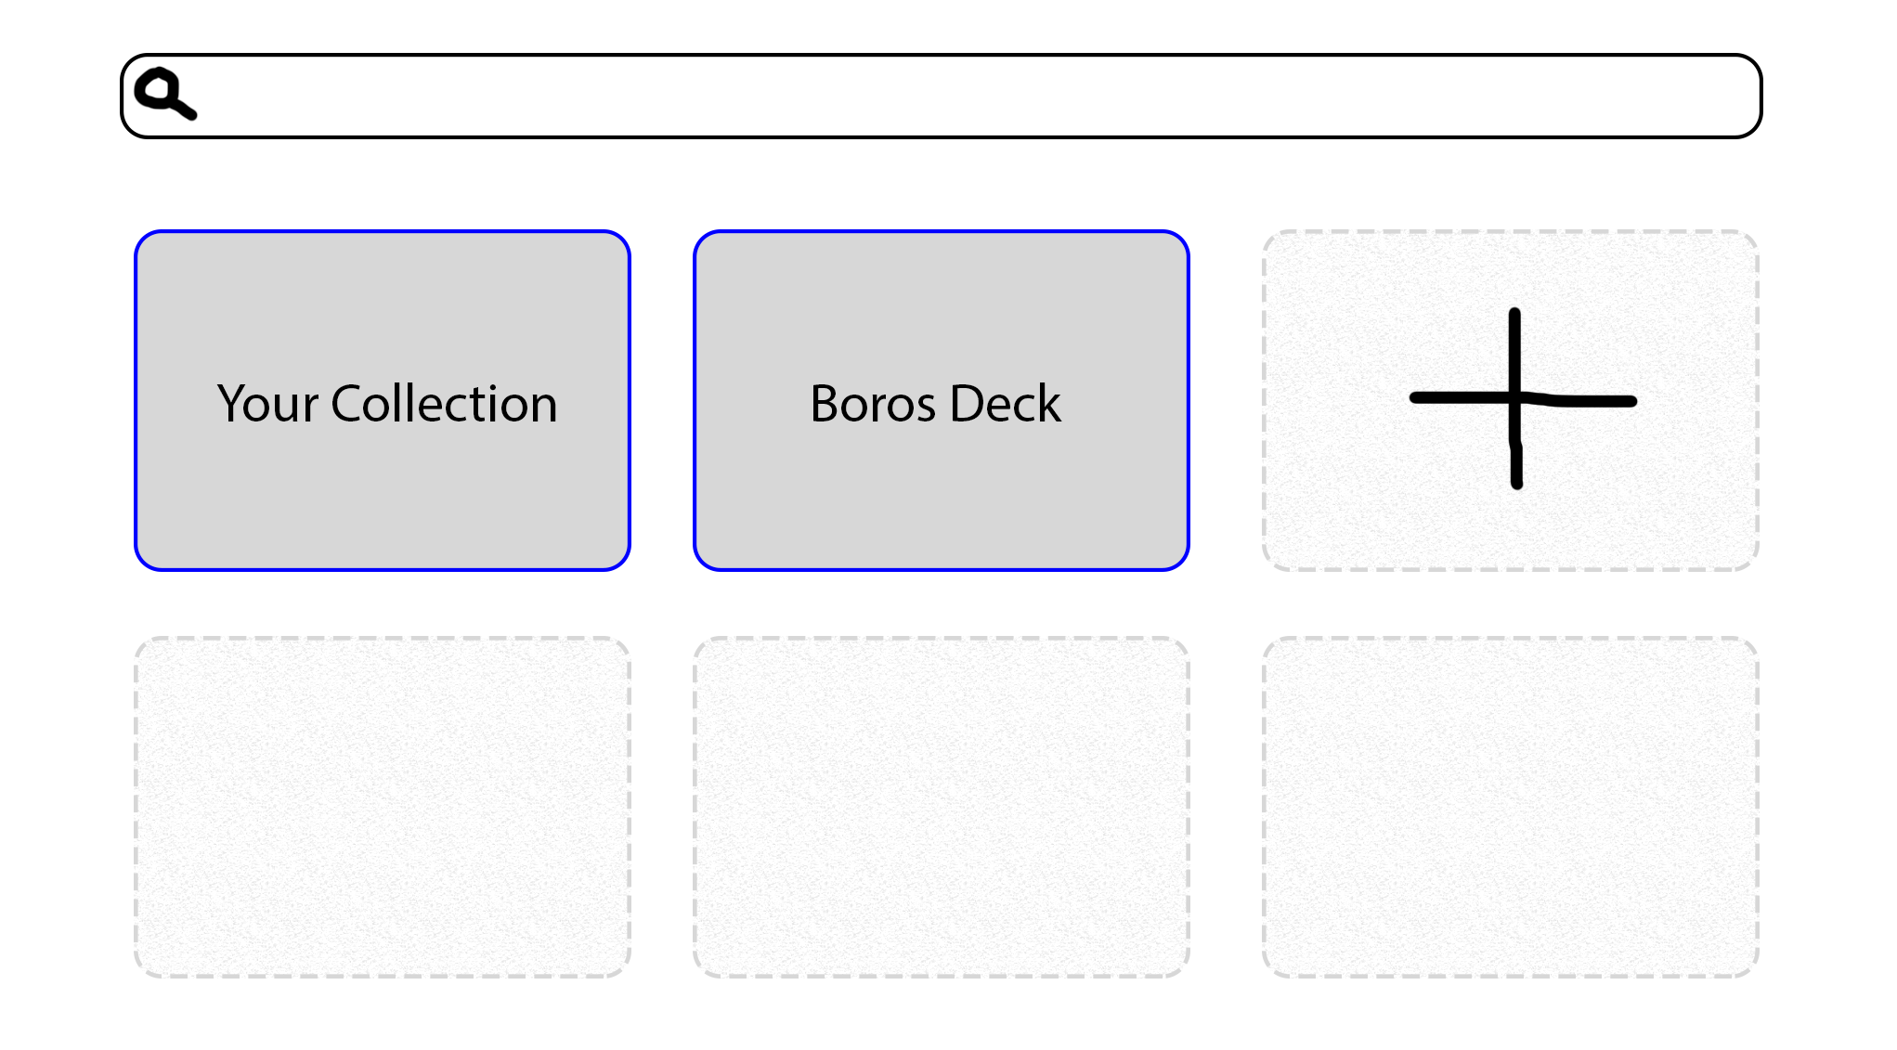

Card Viewing Screen : Shows all data that would be shown on a real card, in similar layout. The actual card will not be shown.

